1. Create an SSH Key pair (PuTTygen)

1. Copy the SSH public key and paste it into your VM SSH key area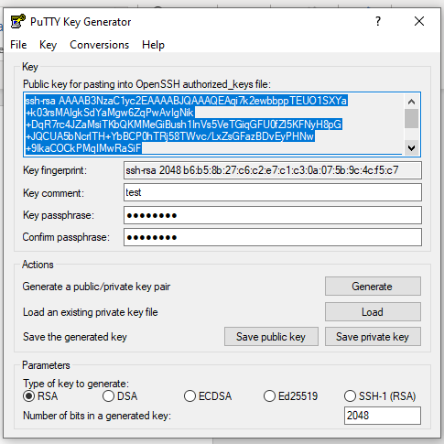

1. Go to putty and add private key before logging in.

